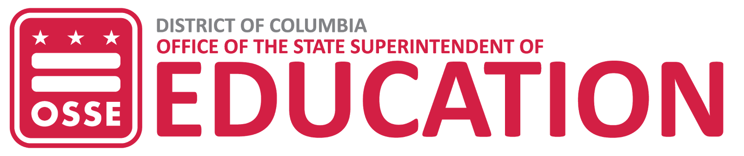

School Meals Program Application
Required Documents Checklist
The Office of the State Superintendent of Education (OSSE), Division of Health & Wellness (H&W) serves as the State Agency (SA) for the District of Columbia. As the SA, OSSE is responsible for overseeing the administration of the federally regulated Child Nutrition Programs (CNPs) operated throughout the District. Orchard is the SA database that supports online applications and compliance monitoring for CNPs.

This checklist has been developed to assist School Food Authorities (SFAs) with preparing and collecting forms and documentation for their application submissions. SFAs should ensure all documentation that is outdated, contains information and/or signatures that are no longer valid are updated during the annual application process. Forms requiring signatures should be signed by current SFA representatives as applicable. The Orchard Library contains templates and guidance documents for all CNP applications.

Timeline
The annual school meals applications are available in Orchard effective June 1st. All SFAs must submit their initial or renewal application by July 30th annually. Applications submitted after July 30th may impact the effective date for reimbursement. Once an application is submitted, it will be reviewed by OSSE staff and approved or returned for modification within three business days. Modifications are due from the SFA within three business days. OSSE will provide all SFAs with a notice of determination (NOD) once the application has been reviewed and processed. The NOD is uploaded within the application in Orchard.

SFA Documents

Organization Documents
- Payment processing forms (ACH, Master Supplier & W9) are no longer collected through Orchard. These forms are distributed and processed through the Procurement Center of Excellence (PCOE). SFAs who are already receiving payments do not need to contact PCOE unless they are updating their mailing address for payments sent via check or changing direct deposit information. SFAs that need to update or provide direct deposit information and or payment mailing addresses should email PCOE at DCvendorsupport@dc.gov or call (202) 724-4477, (press option 1 then option 2) to reach a vendor maintenance specialist.
- SAMS Registration – pdf of valid registration; for details, refer to the Creating a DUNS number and SAMS registration How-To document; the date on this upload should match the date entered on the Program Information > Organization Information tab.

Single Audit Report or Exemption Certificate (if applicable)
  - A-133 Audit Report -OR-Financial Year End Report and Exemption Certificate
  - If the SFA will not be providing an A-133 report, then the Exemption Certificate is due with the application
  - A-133 Audit Report and Financial Year End Report are due by Dec. 31st
1050 First St. NE, Washington, DC 20002 • Phone: (202) 727-6436 TTY: 711 • osse.dc.gov

Required Documents
- Disclosure of Lobbying Activities
- Drug-Free Workplace
- Hazard Analysis & Critical Control Point (HACCP) Plan
- Local Wellness Policy
- Public Notification: Screenshot of website displaying URL & post of public notification

Private School
- 501-C(3) – Private Schools only

Pricing Program
Letter to Household - Required for SFAs operating pricing programs. Not required for SFAs operating Seamless Summer Option (SSO).

Supplemental Documents
- Assignment of USDA Foods Planned Assistant Level (PAL) Agreement – Only required for SFAs that contract with a vendor or Food Service Management Company (FSMC) and who have authorized the vendor or FSMC to utilize the entitlement on their behalf. The allotment can be found under
Notifications > Planned Assistance Level Notification (Estimate).
- Emergency Meal Plan- only required for SFAs implementing emergency meals.
- Severe Need Data Sheet – SFAs do not need to complete this form for sites that participated in the Community Eligibility Program (CEP). Only required for multi-site SFAs.
- Policy Statement – SFAs may provide their own policy statement opposed to the State Agencies policy statement. SFAs who accept the State Agency policy statement in the CNP application are not required to provide an additional statement.
- Waiver Request Form (Misc.)—Specific to the 2021-22 school year, upload the waiver request form in the Misc. spot.

Procurement Documents
- Food Service Contract(s) - Only required for SFAs with a new contract beginning this school year; SFAs should upload all contracts that pertain to food services.
- Extension of Food Service Contract –Required for SFAs who are utilizing an option year in a current contract; upload all documentation related to the extension
- Food Service Contract Modification(s)
  - Required for SFAs contracting with vendors or FSMCs due to updates in federal regulations;
  - Required for other modifications to existing contracts;
  - Upload all documentation related to the contract modification
- SFA’s procurement procedures and written code of conduct

The following documents are required for all companies the SFA is contracting with for food services:
- Vendor’s Basic Business License (BBL)
- Vendor’s Certificate of Occupancy (COO)
- Vendor’s latest health inspection

Annual Documents
- Financial Year End Report - Due by Dec. 31st
- FNS 742 - Due by Dec. 15th
- FNS-874 - Due date will be communicated at a later date, if applicable

Site Documents
The following documents are site-specific.

Required Documents
- BBL must not be expired. BBL must also ensure that the school name and address are accurate and current.
- COO - Valid COOs are required for all sponsored sites.
o In cases where a temporary COO is issued under situations like emergency, construction, etc., SFAs will have to upload current documents.

Supplemental Documents
- Breakfast in Classroom (BIC) Waiver (template forthcoming) - Upload if applying for this waiver. OSSE may grant a waiver for one school year to an elementary school required to serve breakfast in the classroom if the SFA submits a written action plan to OSSE showing a strategy to utilize an alternative breakfast serving model that will enable the school to reach the 75 percent breakfast participation rate.
- Pre-Approval Visit Review Form – Only applicable for SFAs opening new sites or buildings. OSSE will schedule the site visit.
- Severe Need Request / Supporting Documentation – only required if the SFA is requesting a new site be qualified for Severe Need breakfast reimbursement. Not required for SFAs operating SSO.

